

# 1

Love - The Extraordinary Hope

by himanshu bais

contains 59 poems beautifully crafted

HAPPY READING!





Shabd toh bas itni likhi hai jo ek saans mein keh jayegi par baatein isme sare maan ki sammajayeji





Nadee ke rahe sarall hoti

tho ye jharne, jheelen, ghaatiyaan itne khoobsurat na hoti





Akash ganga ka tara hu ek disha dudh rahe ho tum, manjil tumari mei nahi kinara dudh rahe ho tum





Intezaar tha shaam ka chand keliye baadalo mein dikha tha ek pal keliye, baithu ise roshni me ya fir ek aur shaam hai intezaar keliye





Baatein hai ghere, in yaadon me there, un yadon ke bateein me tumko pata hu, jo saaj sun raha hu, ye bhram hai mera ya jhalak hai tumhari





Na suraj ki hararat na chand ki aabha, tum ho inn sitaron si khubsurat, tum se hi hamaari zindagi ki jagmagahat





baanau chand sitare aasman phool ya khoju bhav se shabdon ke guche, kab honge vo baat jisme kadam kadam par sanjoe honge maan ki saaj se likhe hue Kuch pal... sacche





Likh toh du magar shabdon ka irada kuch aur hai, Bina sawal jawaab puch rahe ho, ae haseen kya jurm hai mera ise agar magar ki dager mei bin chirag chod rahe ho…





Kaas thodi der ruk gayi hoti, badal gaye vo jazbaat ke vo baat boldi hoti, tham ke mera haat kaas thodi der ruk gayi hoti

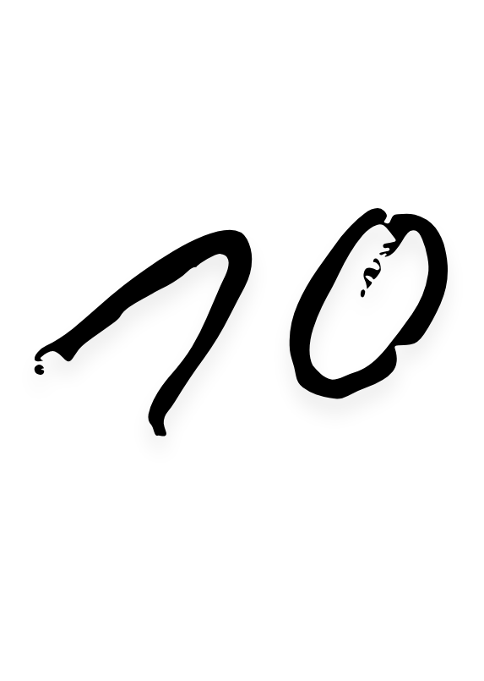



Khamosh hu isliye shayad ki vo shabd mai na chun paun jo khamoshi meri bol rahi hai, shayad vo na sun paun jo saansein thumari bol rahi hai...

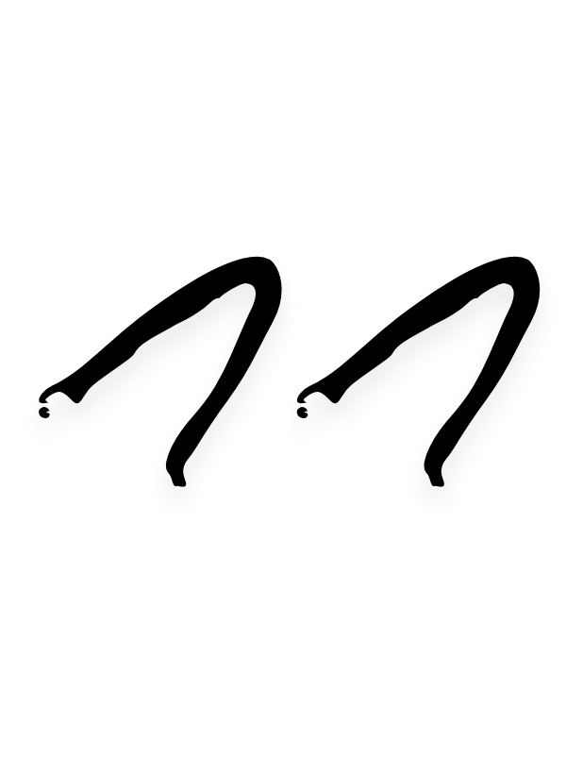



Sawal kathin hai fariyaad kiya, rasta chuna hai muskil yaad ye jawab... aaya

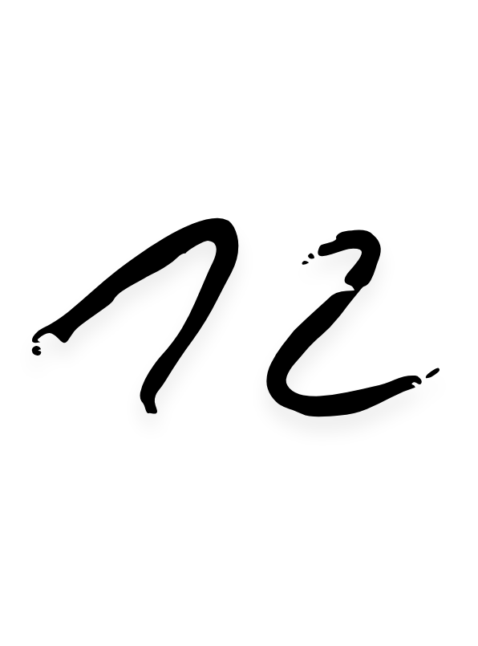



Socha chodu duniya ke chochale... Khokhle hai sare vaade unki yaade. Par maan phir le aaya woh door jo bandhi hai tumhari aur.

Pata nahi kon bun ta hai ye raste jo le jate hai mujhe tumare vaaste

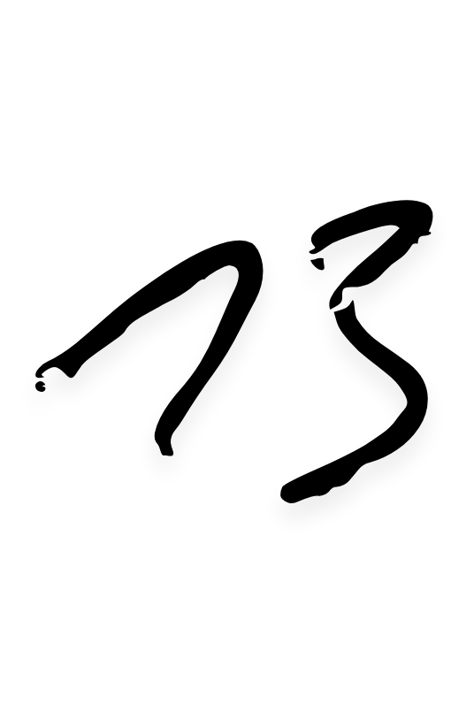



Kush ho apni yaad ko baaya karke naki tumhari yaad me fariyaad karke

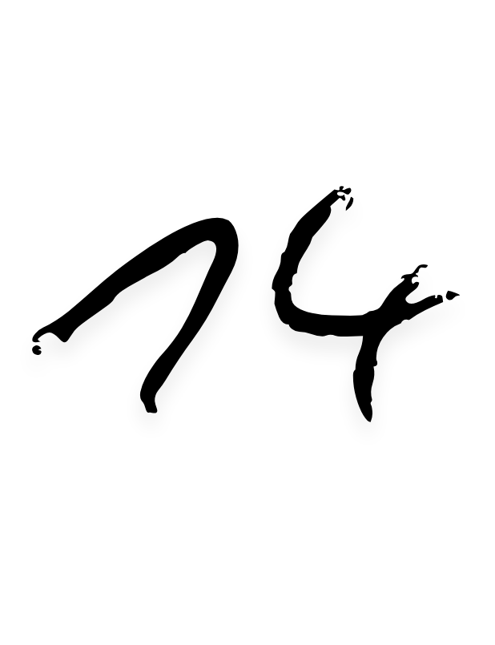



Pata nahi likhta hu sakoon mein ya sukoon ke liye…

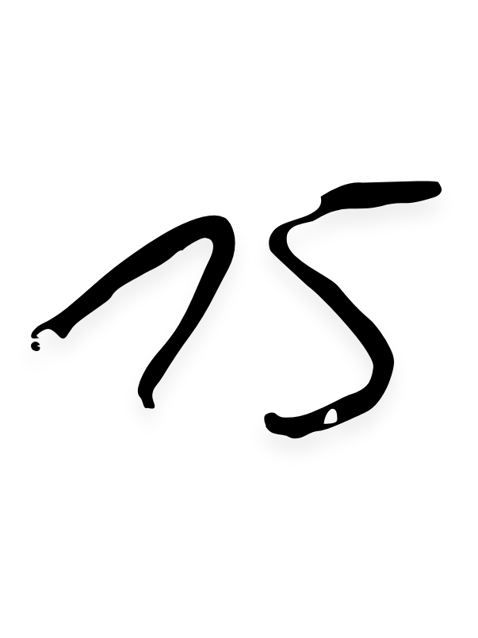



Dekhi ek tasveer tho ek khayal aya likhun kuch...

Par ek sawaal aaya...

Sawal kya kuch dhayan aya...

Maan jo phasa hai khayalo mein kaha dhayan dega sawalo ka jiska jawab nahi hai... Khwabon mei

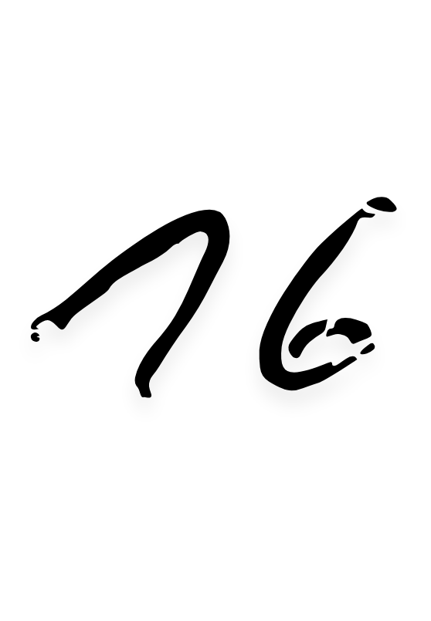



Ghum hu apne khayalo mein un shabdon ki jalon mein aise jugnu chhupe dhund jaise tare timtimate asma me, dost ka aana uss hawa ki tarah jo thand me sarsaraahat deti hai dhund bekher kar suraj ki kirnon se hararat dejati hai

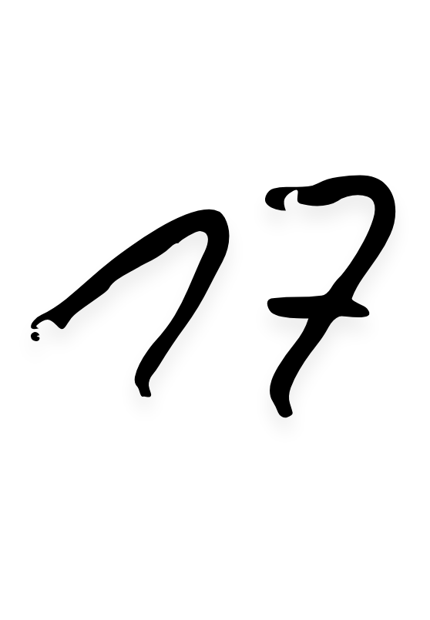



Kya samjhenge jo jinhone panne raat liye kitab ke mere apne kitaab niharne ki ijajat na di…

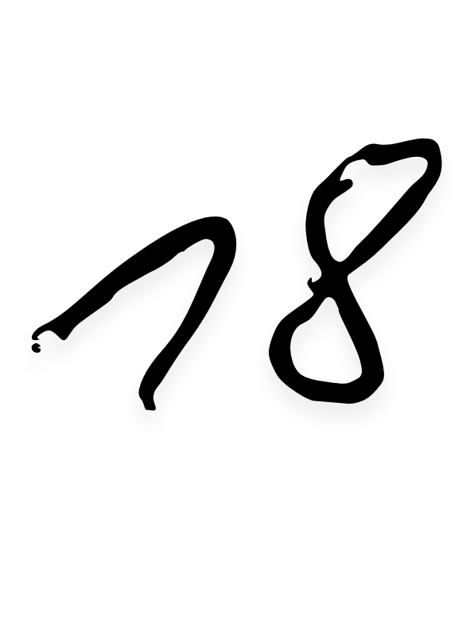



Din whai baat jab tum karo, raat whai shant jab tum raho, raat chandni wahai hatho me hath tabhi…

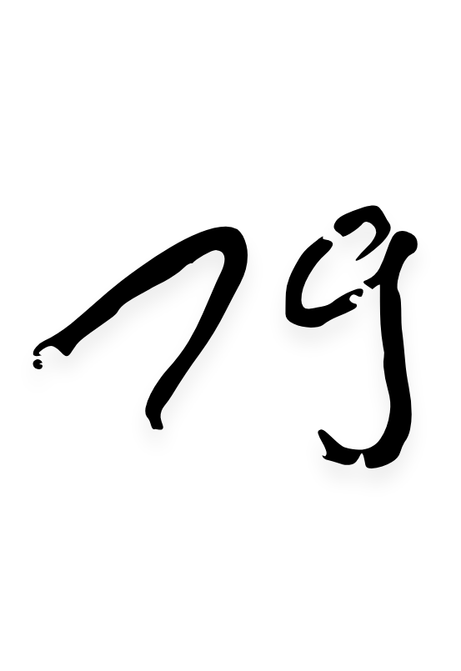



Priye maafi chahunga...

Jo beet gayi woh baat rahi, jab milenge jo kahogi vo baat sahi.

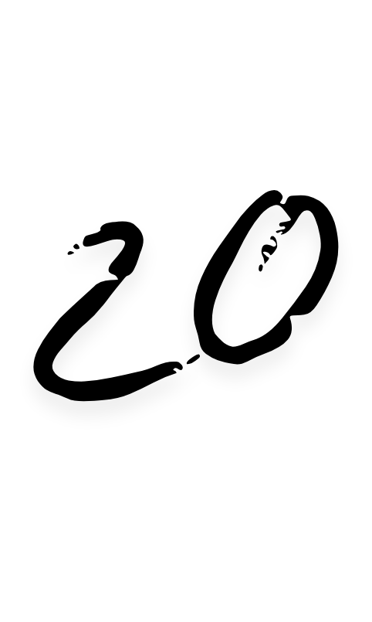



Ubaal marte ho jazbaato ka zahen me, taherne ka khayal jatate ho, gajab hai... kya chahte ho…

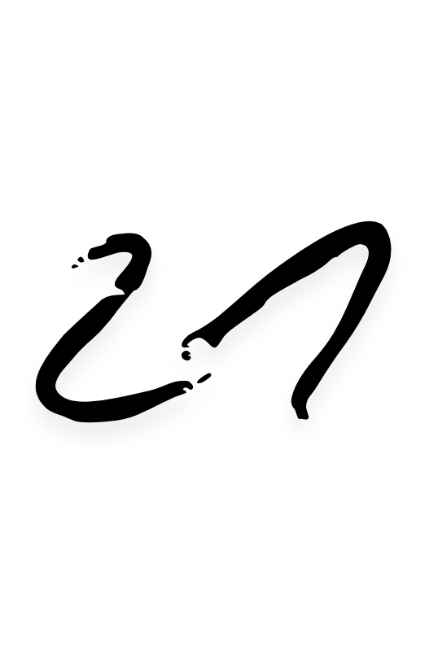



Ye adbhut jasbaat churae hai bhav se thumare lauta raha hu ye shabd mein lapet ke...ye guldasta Shayari ka app keliye

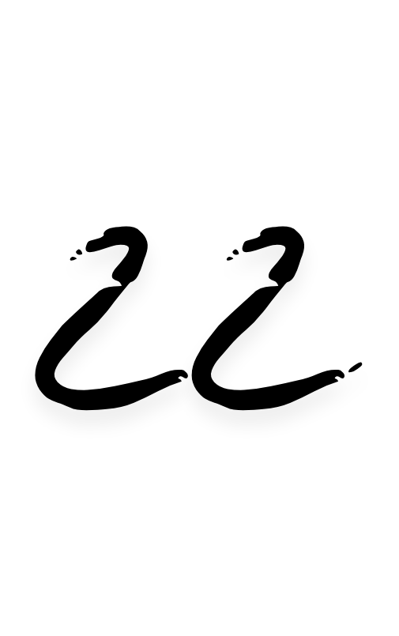



Nafrat hamara kirdar mei nahi, na zarurat mein dekha tha, na kabhi qurbaat sa chahaya, saaf tha dil hamara saaf hi rakhenge…

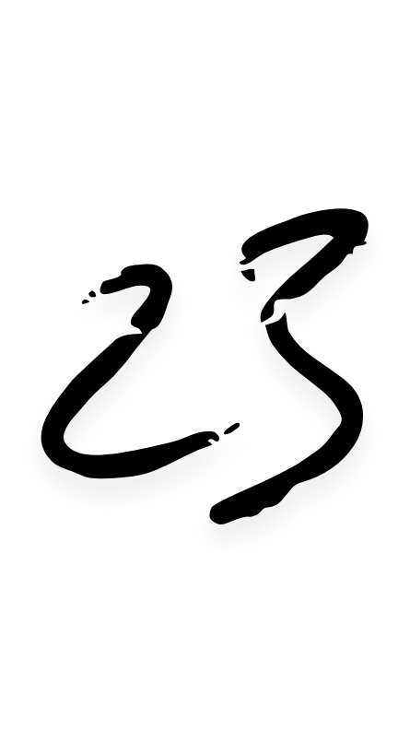



Log yaadon ki baat karte hai hum yaadon se hi yaadon me baat karte hai…

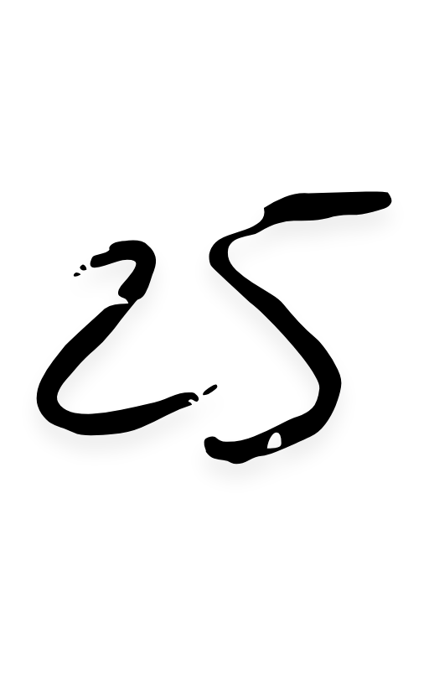



Ek kirdaar esa likhu haathon mein haath hamesha sath rahe, har baat pyar aur naam uss kirdaar ka mei likhu aur vo tera rahe…

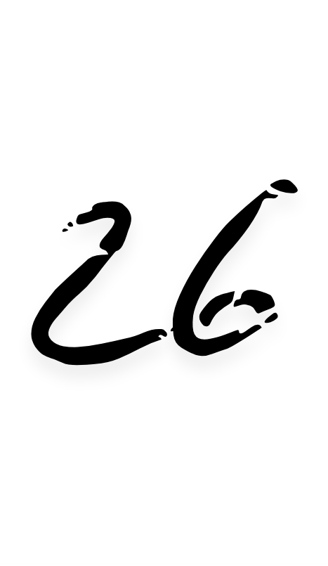



Phele barish mein mitti ki khushboo toh koi bhi likh dega, hamse pucho tho un khushboo ki yaadon se kahaniyon ka kissa jiska rang pyar, sagar ki gehrai se akash me niharti dundhlate chandni mein khamoshi ki jagmagati saaj se tumhare chehre ko kon... Kon aise likhe ga…

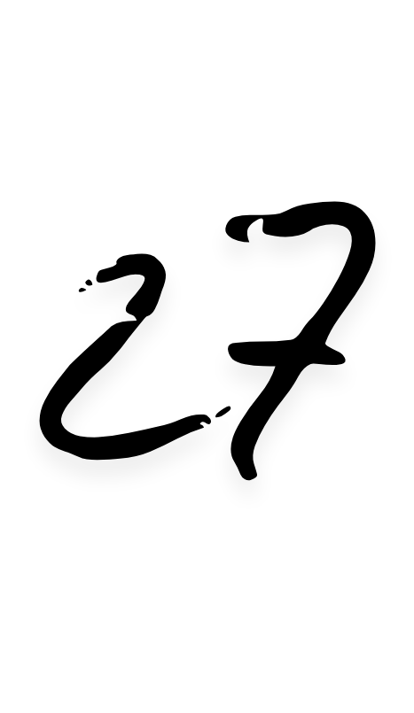



Aakhri hi sahi, soot samet... Bhav shayad namunkin sahi...

Shabdon ke jariye lauta raha hu...

Inn nayan ne jo Diye the geet sureeli, aaj bhi dill kachoot raha hai...

Jo baat thi kabhi aaj vo rahi nahi...

Shayad ye shabd kudh se kudh ke liye likh raha hu

ye khayal aa raha hai...

Ye kya kar diya tumne, na sawal aa raha hai...



Bas shukrguzaar hu samay ke liye jo tumne na jane kyu mujko diye apne man me... Na jan-ne ka irada hai...

Aakhri hi sahi…

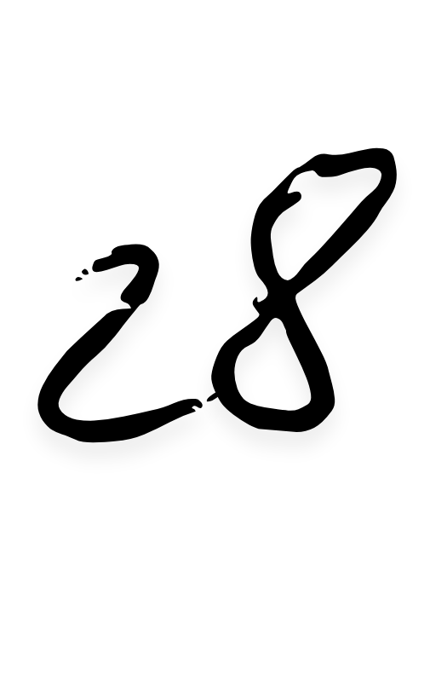



Manpasand rang, jawaab ek shabd mei nahi...ek do shabdon ki rekha mein batana chahunga...

Hara kyuki ped... Lage hui usme seb lal... Garmi mei Sukoon deti hui uski chayan ki kalima... Hawa mein samai gagan ka nelapan…

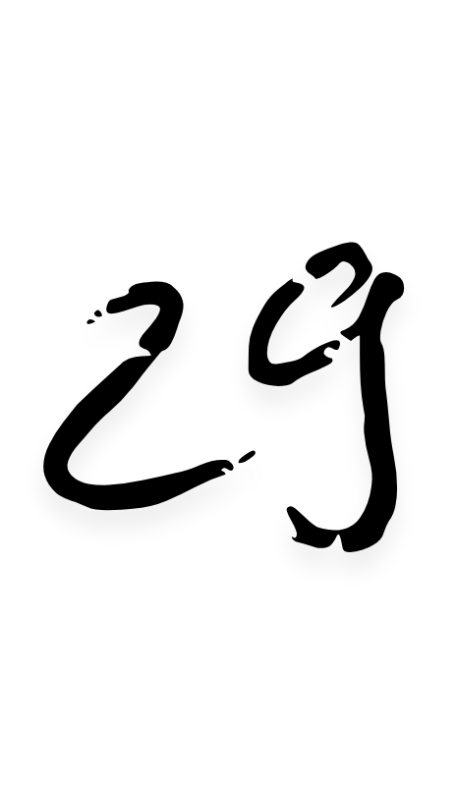



Kuch bhav chod diye, kuch hai pardo mei, binu shabd kaha se sari hulchal thami hui…

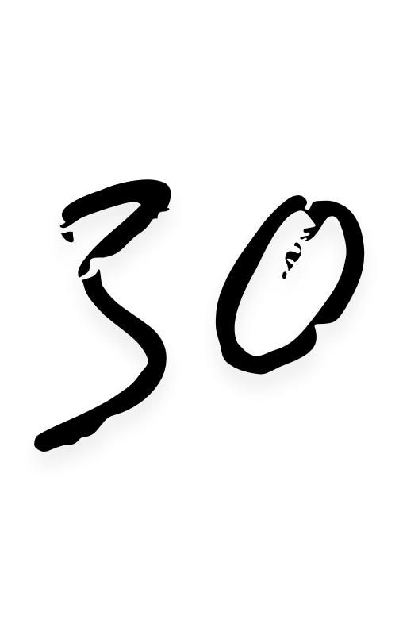



Jana hai baato se, bin jane dur baithe mana hai jazbaato ko...

Pata nahi inn palon ko kya kahu jo muskil hai samajhna lafzon se par dil me utarte hai... Nazo se…

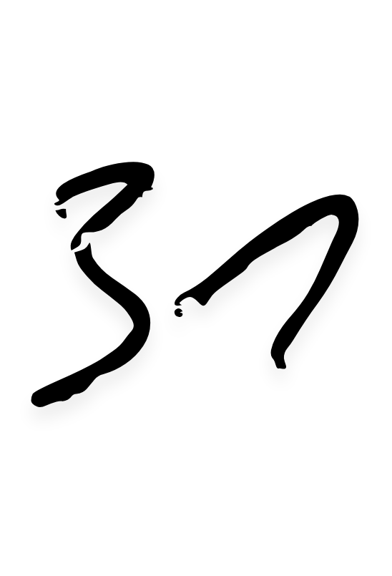



Lag raha hai jag raha hu sapno me, hakikat lubhati nahi... Lagta hai yaad hai jo hai hi nahi…

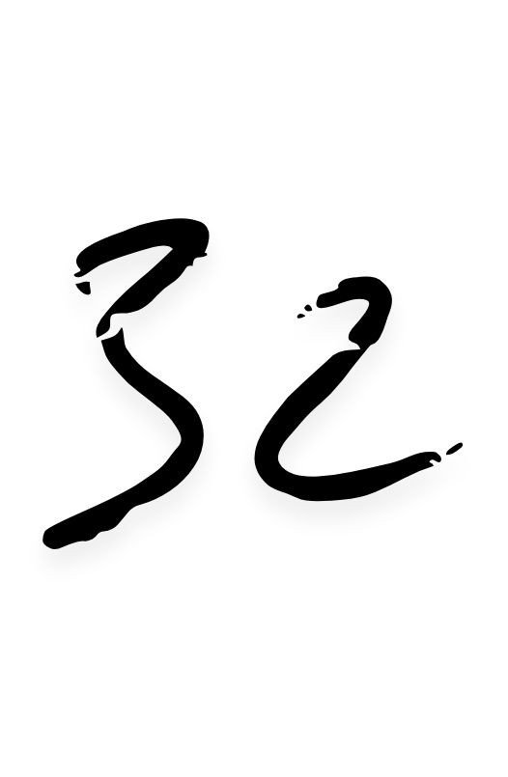



do pal ek saath kudh se hi jee raha hu, ek tumhare... ek mera…

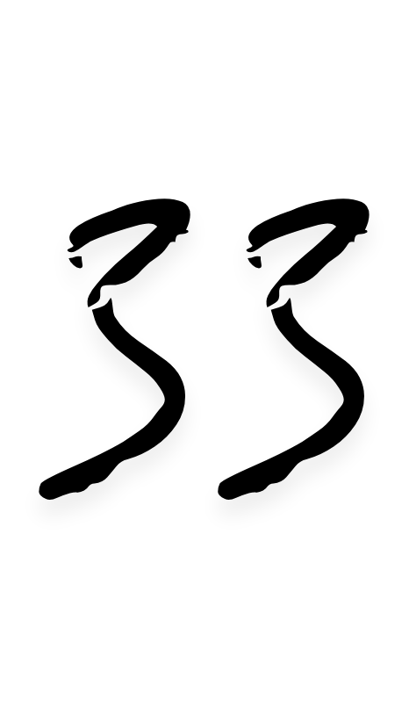



Padh teen shabd pyar ke khawab bun raha hu, chitthi likhi hai bin pata... Pata nahi kya raaz sun raha hu…

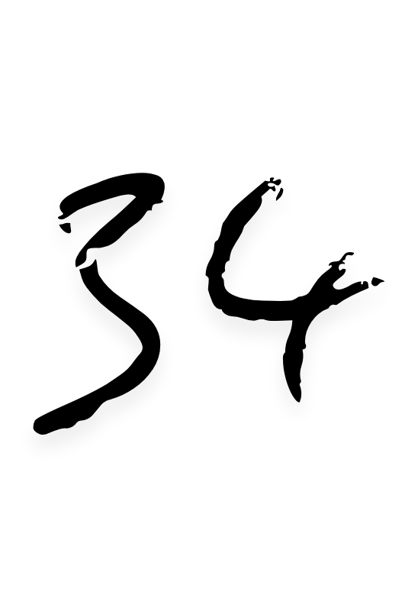



Likhu kuch khaas, ab tum hi batao vo ehsaas jo shabdon mein bane jaise ret bani pani ki koshisho se khubsurti bekheri hawaon ne lakir ban kar...

Agar maan janta vo ehsaas tho banata kuch khas... Ab jo dhumil si chavi jo pardo se jhalki, banke ujala badalo se chamke...

Dur se niharti aankhe kya chand kya taree...

Bas kuch is choti se poem ki tarah...

Jo lage ek jaise par bikhri bikhri...



Ab batao kaise jodu inn ehsaas ko paas hai dur se..

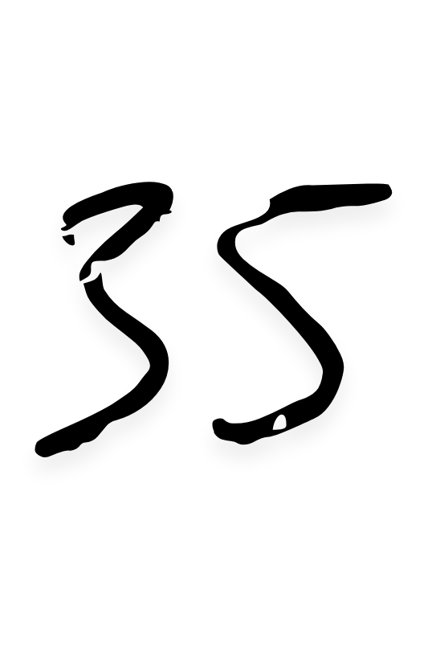



Shabd samete hai jaha jo bhi dekhe gagan ke tale akhon me base kar maan me rahe vo likhta hu mehsoos kar dhadakte dil ki ankhon se jhalakti gehraiyaan padh kar…

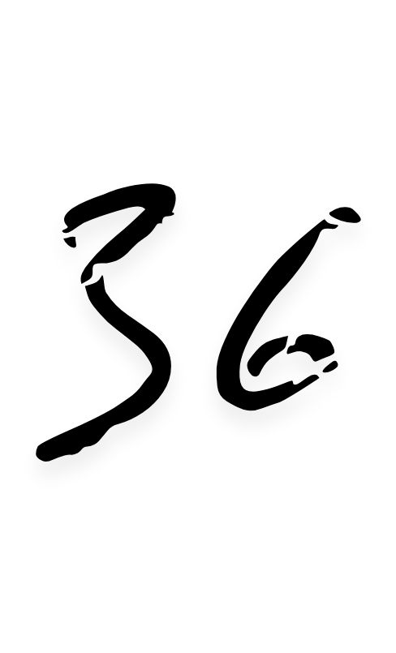



Bin tere, gane ka bas matlab hi samjh sakta hu...

Pass tere, do shabd... saath mein geet lagte hai...

Haathon mein haath jab, ghadi ki tik tik bhi sangeet lagti hai…

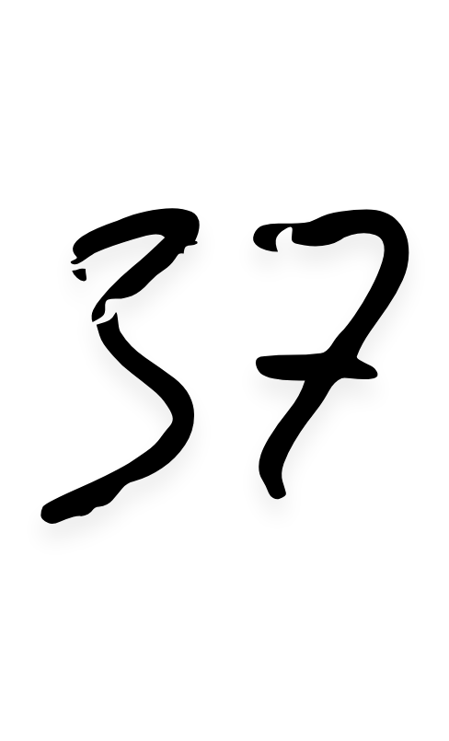



Living in the tangents of life...

Expecting them to merge alright...

Sailing over what's now and next... Future gonna be wow... I guess

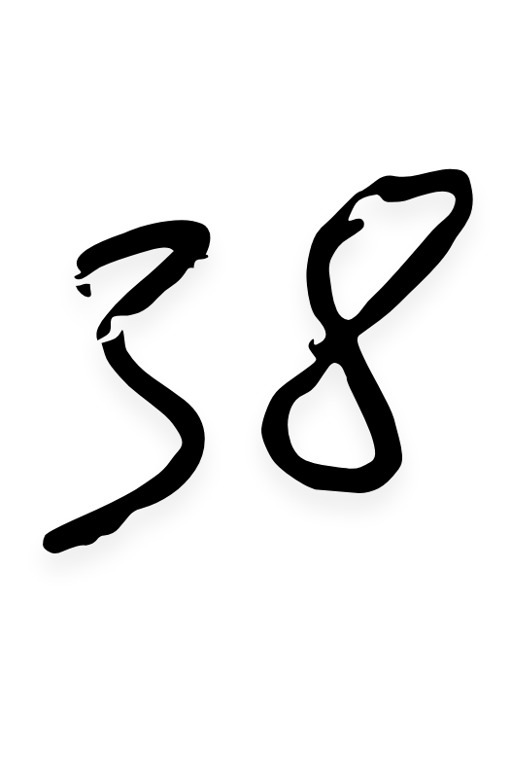



Likhe te the ham kisi ke liye, ab kisi ki yaad me kal barbaad hokar bhi shayad likhenge uske hi liye…

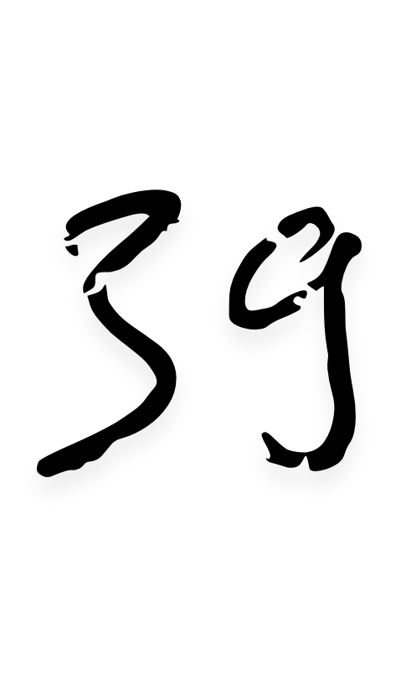



Parinda nahi ud jaunga, jazbaat dil se jode hai maan se samjhe hai... Agar haath mein zakhm hai toh malham samjho, agar akho mai aasu tho rumaal samjho…

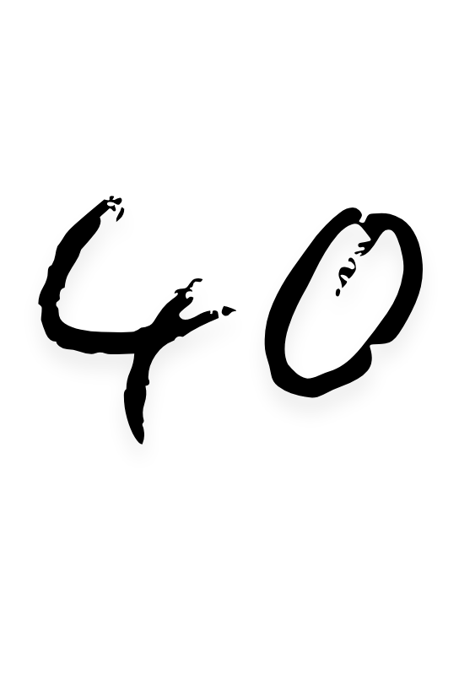



Acha hai maan nahi padhe leti, agar padh leti tho mujhe nahi kudhko hi pati…

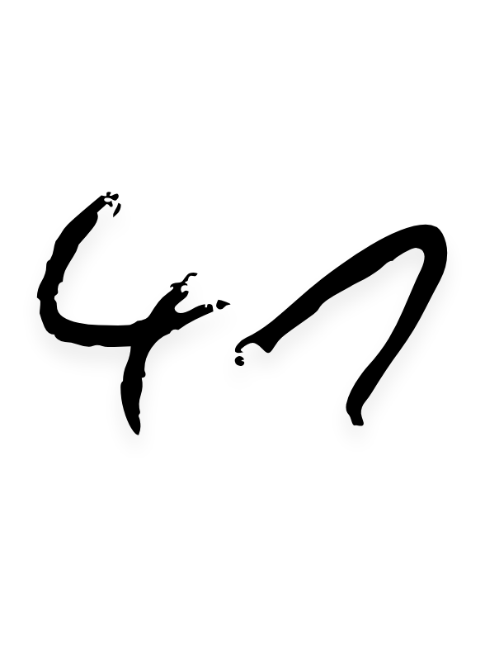



Shabd laya phele bhi par sankoch kayee... Thama hua hai sailaab... Anek, anokhe, adbhut... Agar ye chakravart toh kendra tum, is sabra ka anth aur aarambh tum…

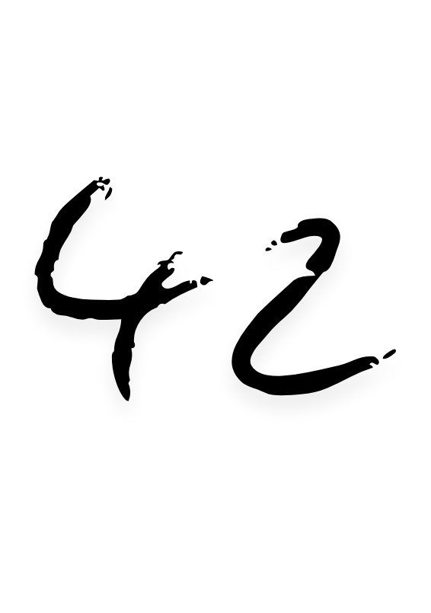



Shaam aane ko, ye hawaae batlati...sajati yaadon ko aur haseen...jo phele se basi maan mei...une aur nikharti jaise phool khele khilkhilate aur uski mehak ghar kar jati…

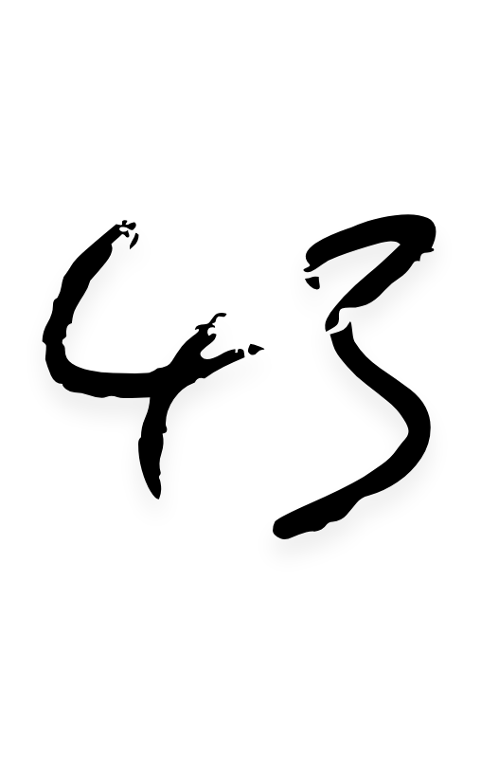



Laga likhu pyar par, kya hazar shabd kafi ek pal par jab hazar pal na-kafi dill par, jiu har pal bar bar…

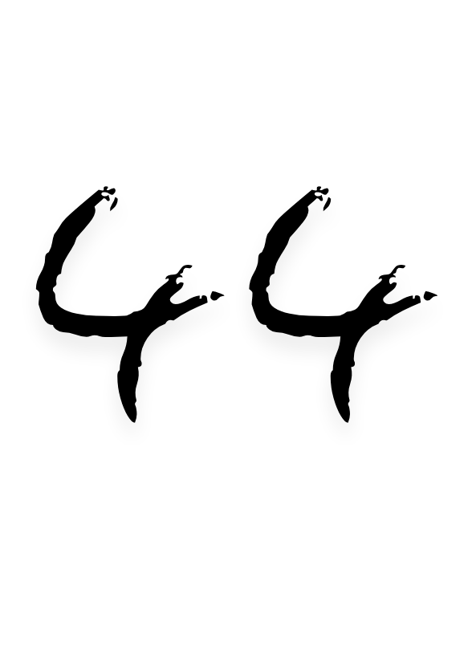



Likhta mei falak pe, jhalak gire zameen mein

jase koi jharna dikhe swarg ke bagh mein raag hai khaas ye...

Shabd rooz ke paar piroye jaise mor nache bagh mein uss swarg ke falak mein…

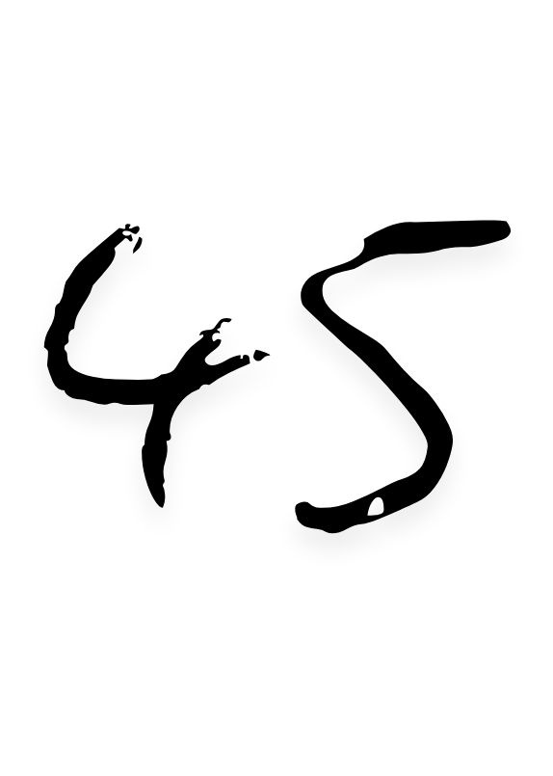



Bas itna hi manga hai shayad kuch jyada hi chaha hai paon har yaadon mein thikana tere... Chalu dhang se tere banke hawa bikheru zulfon ko Ban kar ossh baithu labon par tere

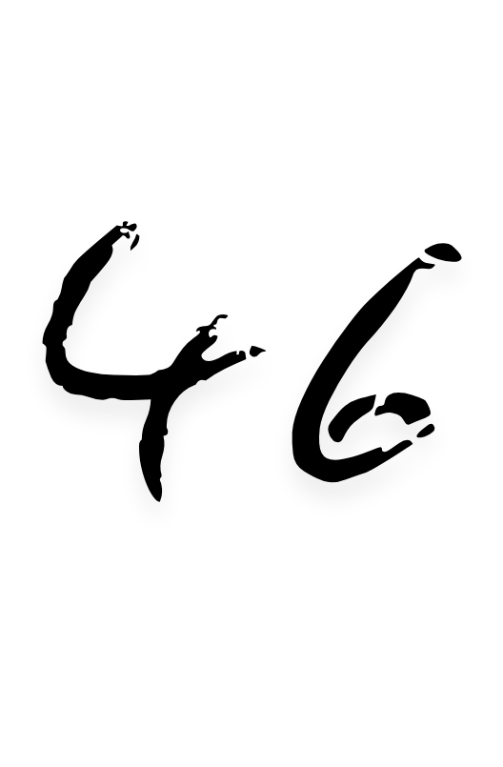



Baate karte ho jaise phool maheke... gali mein aaye ho jaisa rang barse... dill utrrae ho jaise hoor banke... Maan saje ho jaise yaar vaise…

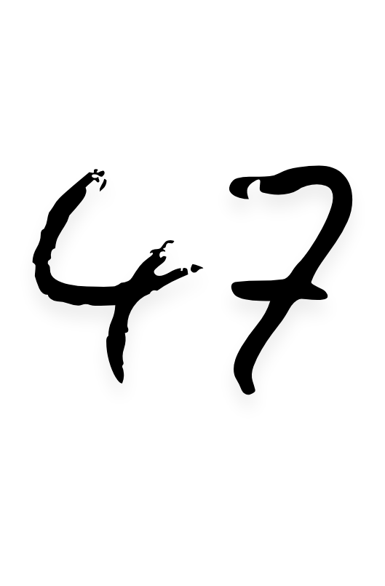



Shabd laya hu har jagah se gagan ke tale jo bhi dikhe vaha se...par inmein jaan kaha se phoonku na tum na tumhare jazbaat na jane kaha chupke…

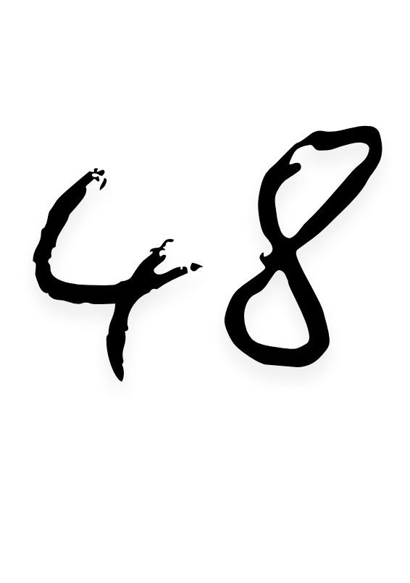



Pata puch rahe ho un galiyon ka jaha hum apna dil bhool aaye the...

Laut na tho yaad se lete hue ana…

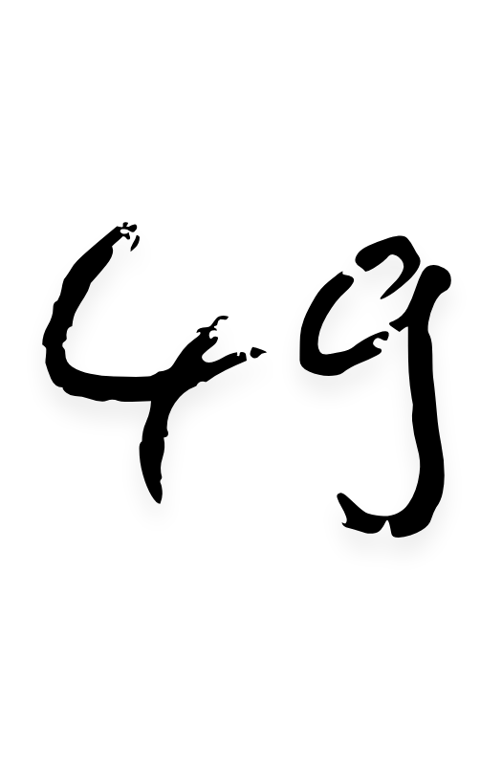



Meri chahat teri jaise chand ki chakor

Maan ko par lagayen teri ankhein...

Ghar kargai teri batein...

Yaadon ki sawari din, khwabo ki pahredari raat...

Saath hi raasta, saath hi manzil…

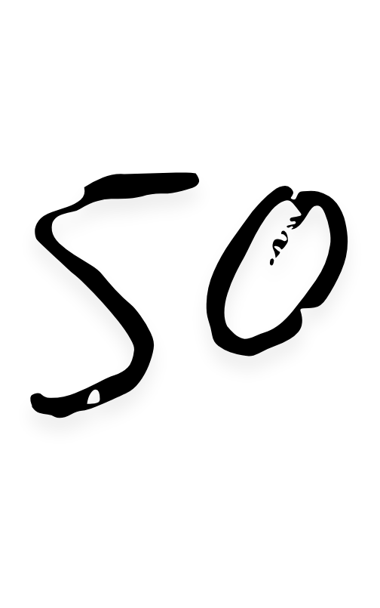



Weham hua fir bhi disha wahi hogi ghagah kahi hogi par wajah wahi rasta kahi manjil sahi aur thikana kahi pata wahi hoga…

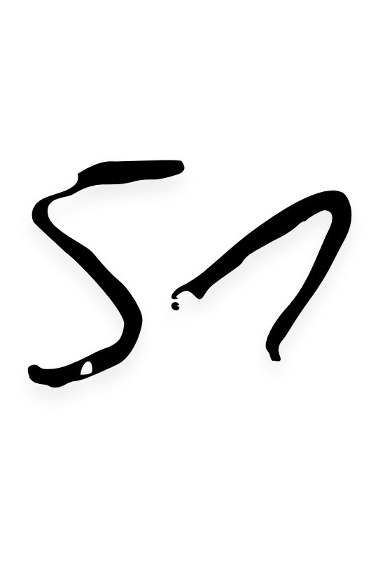



I bring the clouds, you rain it...

I click the pictures and you frame it...

I say I love you and you name it…

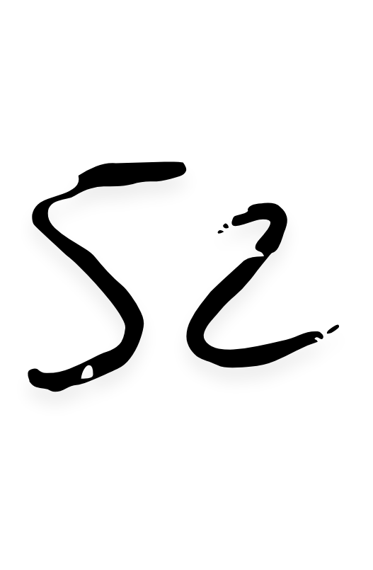



Jab mein tujh ko shabdon mein bayan karta hu tho kudh ko tera sath khada pata hu…

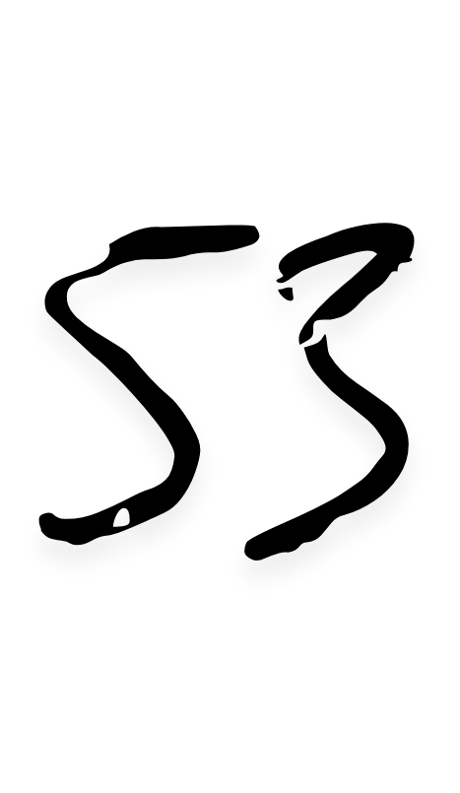



Time runs forward, everything connects backward...

Bleeding future, Leading curiously... Furiously on the plank that i drank regrets, burnt cigarettes, churned truths following fruits…

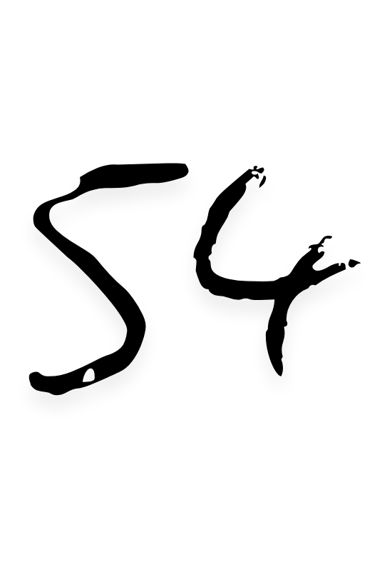



Love so might Closed in a room still so bright Experience the warm finely Want to escape the infinite camly To be here with all the senses In all instances By all chances

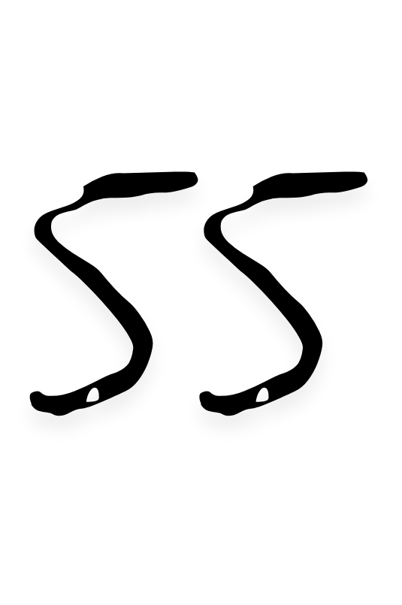



Your talk felt so close, I thought you chose, But it was everyday of yours, alas you made me yours

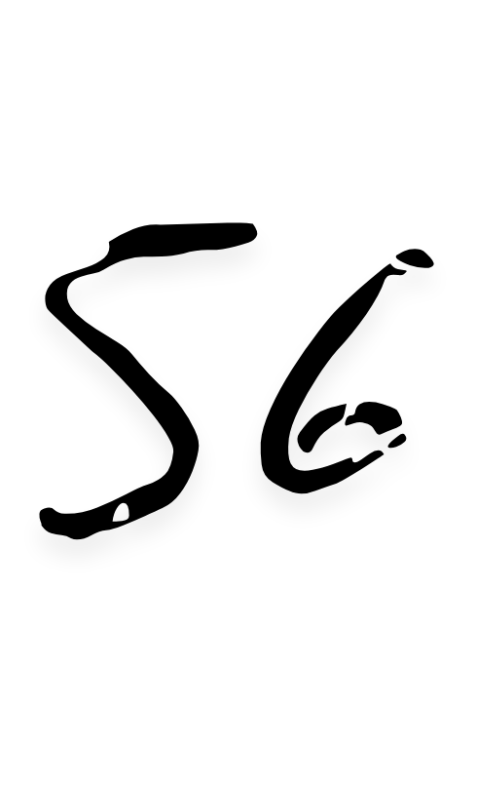



Happiness is all you see but the pillar of horror is what makes you stand so free…

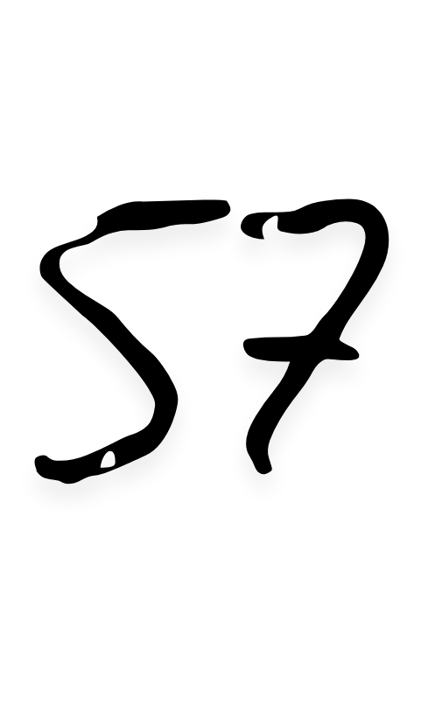



Running from your thoughts is like dancing in rain wishing to not get wet.

Crying eyes hoping to look all dry and fresh.

Shaking hands walking in a straight line.

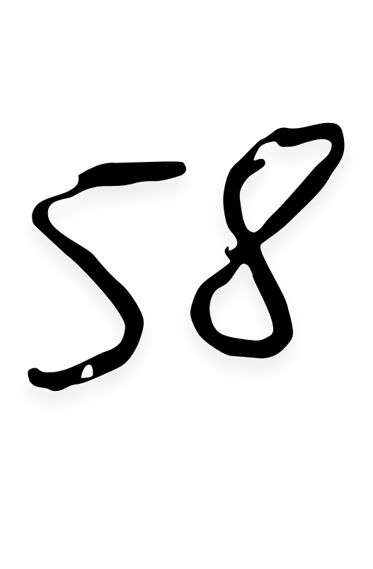



Jis khayal mein tum nahi, shabd bhi kaha rahe...

Jis waqt mein tum nahi, Dhayan bhi kaha raha... Jis pal mein saath tum nahi, Hum bhi kaha rahe...

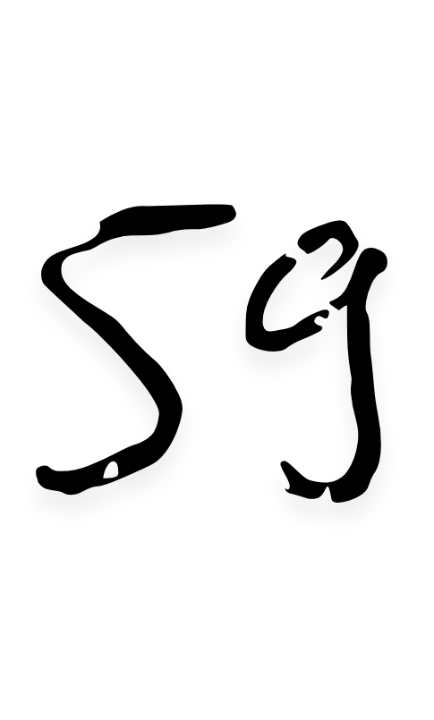



Dekhi duniya pehle bhi, Aaj bhi dekhta hu...

Kal duniya mein tumhe ab duniya tum mein dekhta hu…

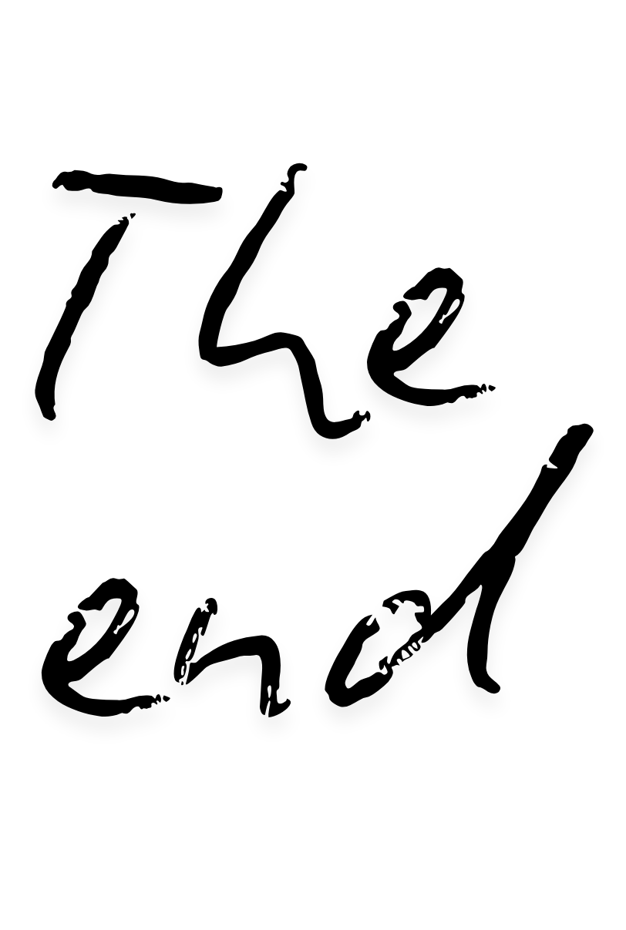

The love that we feel in words...

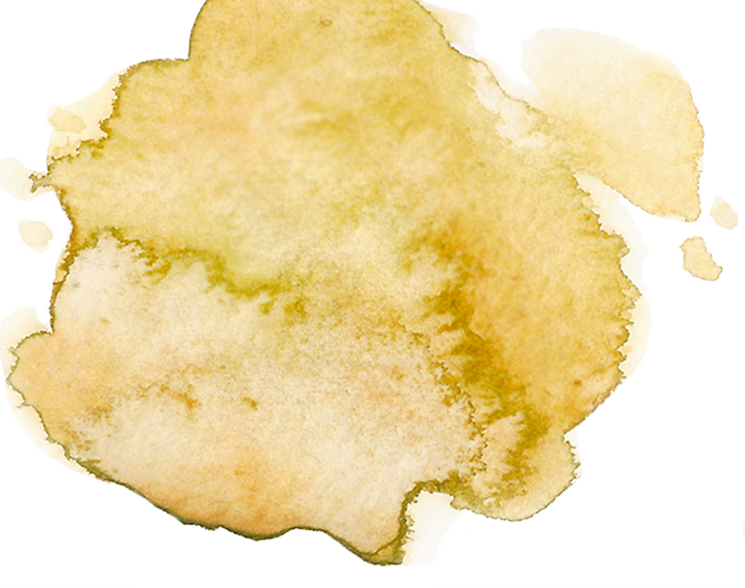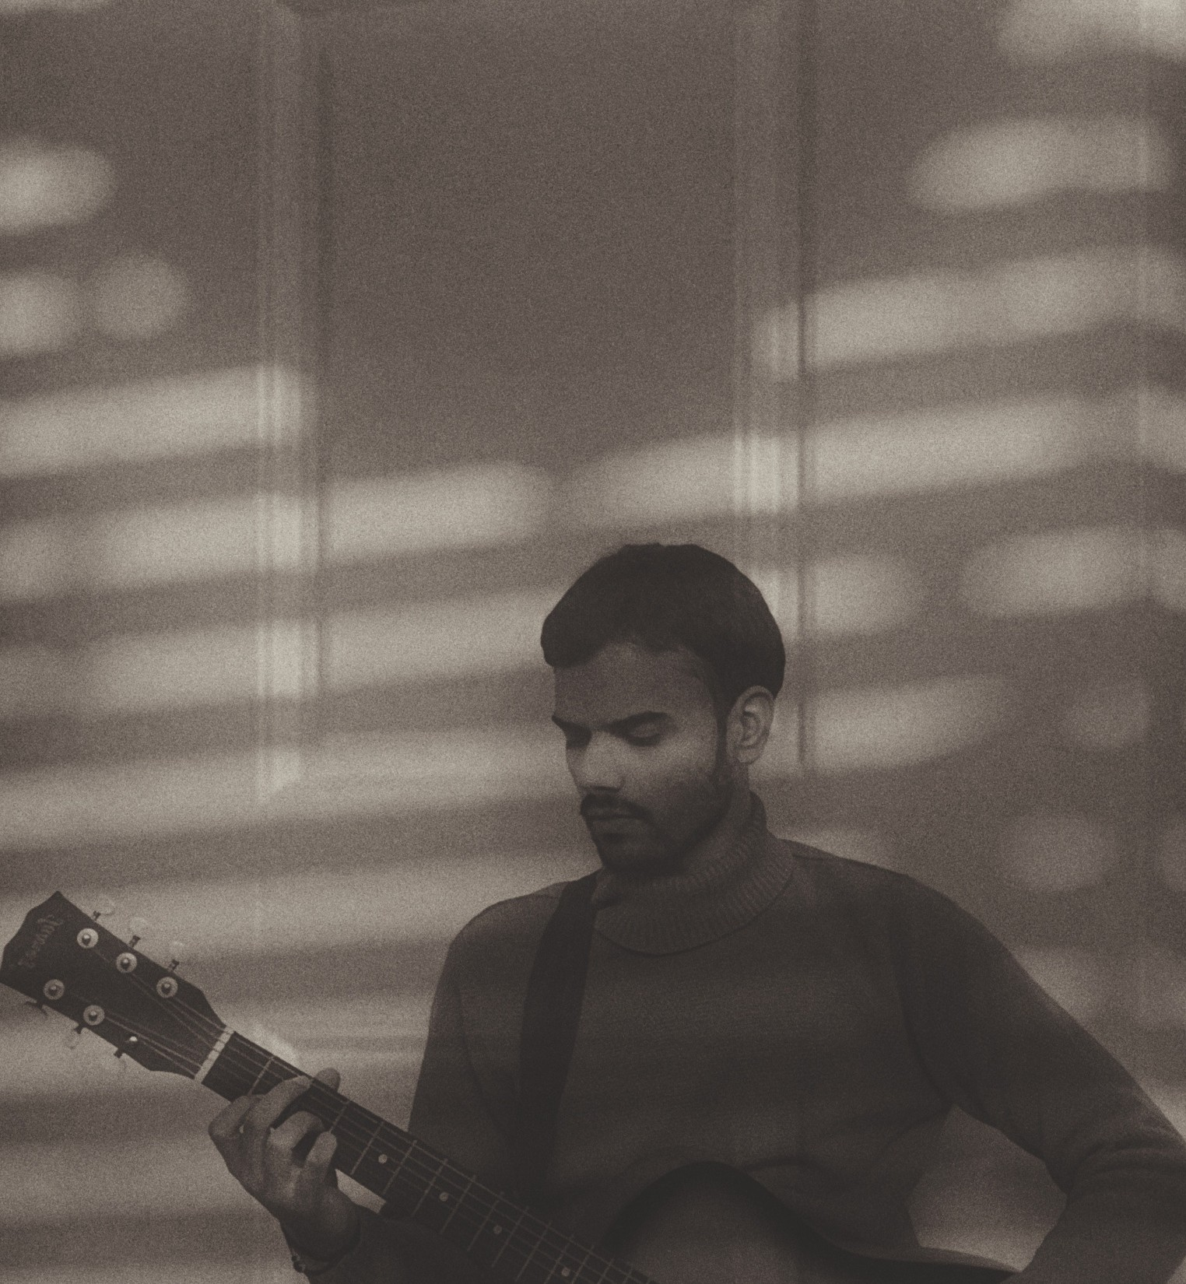

This book contains 59 poems which encapsulates all the moments when you are in love. It motivates you to feel thorough beautifully crafted

words.

*It's me :) m 24*

*I a*